# Appendix A

Appendix A provides details for simulated PV modules. The first and second PV has been modeled and simulated for environmental factors affecting and shading faults respectively in this work. The third and last PV is a low resistance HS fault model, simulated for different HS faults. Furthermore, the PV module's electrical characteristics of these models are provided.

## PV modules' electrical characteristics

User-defined PV modules have been used in this work for PV simulation of the single diode model, shading faults model, and Low resistance (HS) model. The electrical characteristics of the PV panels are shown in Tables 1, 2, and 3. All listed values for the PV electrical characteristics are under normal irradiance and temperature (G: 1000, and T: 25degC).

Table.1 PV characteristics of single diode model

|  |  |
| --- | --- |
| Parameters | Value |
| Peak Power | 213.15 W |
| Voltage at maximum power point (Vmpp) | 29 V |
| Current at maximum power point (Impp) | 7.35 A |
| Open Circuit Voltage (VOC) | 36.3 V |
| Short Circuit Current (Isc) | 7.84 A |
| Number of cells connected in series | 60 |
| Number of cells connected in parallel | 1 |

Table.2 PV characteristics of shading model

|  |  |
| --- | --- |
| Parameters | Value |
| Peak Power | 83.28 W/250W |
| Voltage at maximum power point (Vmpp) | 30.96*20/60 V |
| Current at maximum power point (Impp) | 8.07 A |
| Open Circuit Voltage (VOC) | 37.92*20/60 V |
| Short Circuit Current (Isc) | 8.62 A |
| Number of cells connected in series | 60/3 |
| Number of cells connected in parallel | 1 |

Table.3 PV characteristics of the Low resistance model

|  |  |
| --- | --- |
| Parameters | Value |
| Peak Power | 39.01 W |
| Voltage at maximum power point (Vmpp) | 8.70 V |
| Current at maximum power point (Impp) | 7.67 A |
| Open Circuit Voltage (VOC) | 8.92 V |
| Short Circuit Current (Isc) | 7.89 A |
| Number of cells connected in series | 20 |
| Number of cells connected in parallel | 1 |

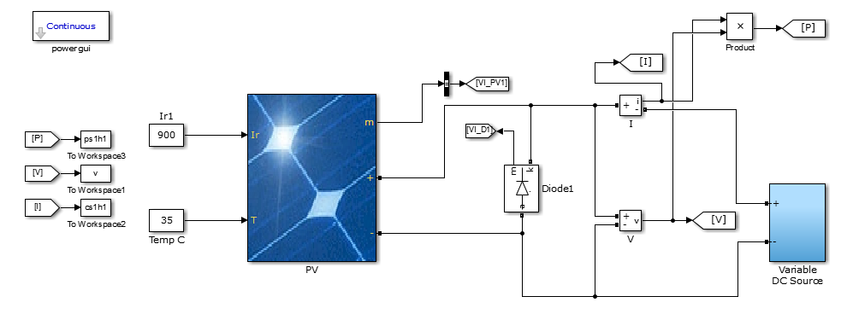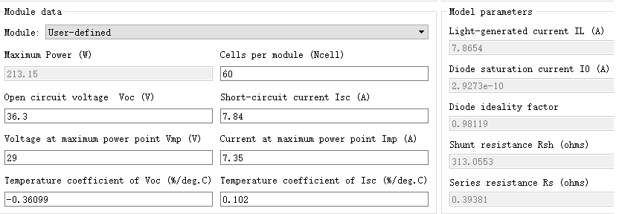

Figure .1 Single diode PV Simulink model (a) Model (b) Parameters

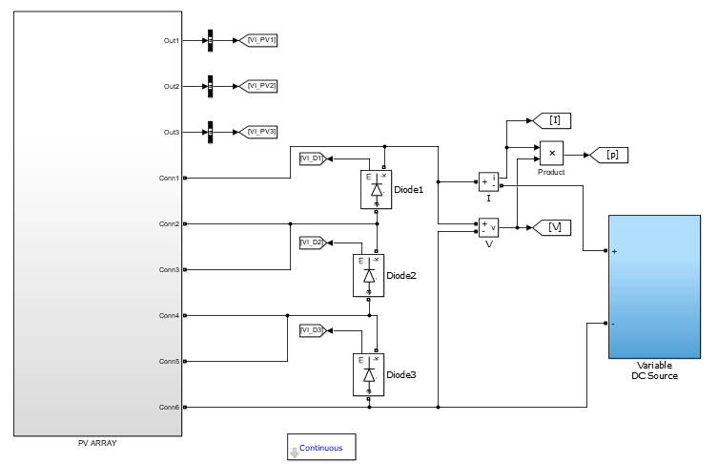

**(a)**

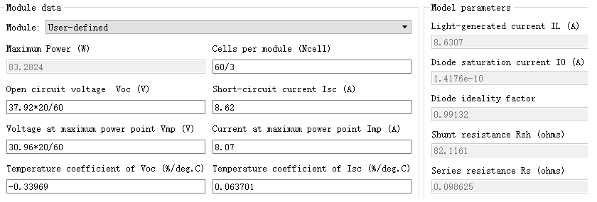**(b)**

Figure 2 Single diode Simulink model of shading PV (a) Model (b) Parameters

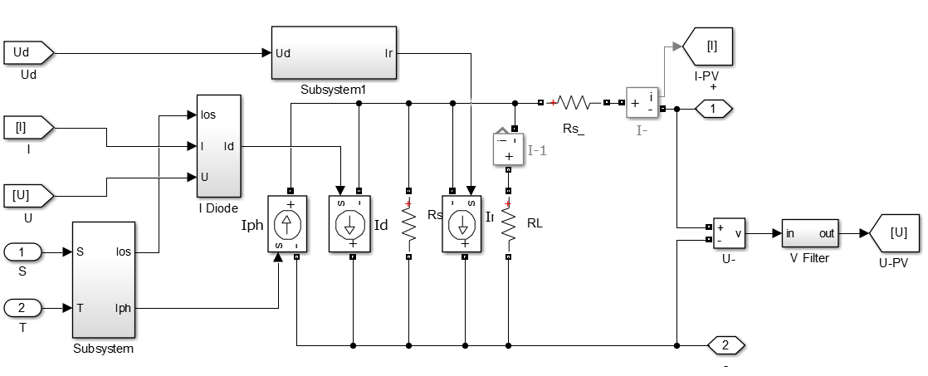

Figure 3 Low resistance defective cell (HS) Matlab Simulink model